Relax Inc. User Adoption Analysis – Key Insights & Recommendations
Problem Statement : Relax Inc. makes productivity and project management software that's popular with both individuals and teams. They would like to identify the factors that best predict future user adoption.
Methodology : An "adopted user" was defined as 3+ distinct login days within any 7-day window, computed by scanning each user's login dates. Overall adoption rate of 13.8% (1,656 of 12,000 users) was observed.
Key Findings
Segment | Adoption rate
Creation source: SIGNUP_GOOGLE_AUTH | 17.3%
Creation source: GUEST_INVITE | 17.1%
Creation source: SIGNUP | 14.5%
Creation source: ORG_INVITE | 13.5%
Creation source: PERSONAL_PROJECTS | 8.1%
Org size: Small | 16.0%
Org size: Medium | 13.6%
Org size: Large | 8.1%

- Signups more than doubled over the ~2-year window (~400 → ~950/month) while adoption rate stayed roughly flat around 15% - growth isn't degrading engagement quality but isn't lifting it either.
- Logistic regression (class-weight balanced) reached AUC ≈ 0.605 — a real but modest ability to separate adopters from non-adopters. At default threshold: recall 0.67 / precision 0.18 on the adopted class (52% overall accuracy) - it catches most true adopters but with many false positives.
- Org size and user signups for personal projects were the two dominant coefficients (~ - 0.3 each) in logistic regression model impacting user adoption negatively, matching the EDA.
Charts to support above findings
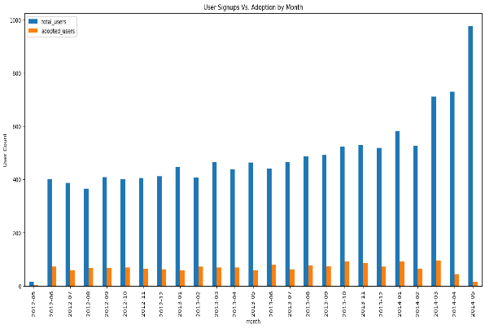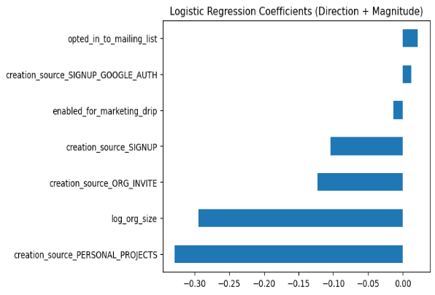
Factors Investigated That Didn't Pan Out
- opted_in_to_mailing_list and enabled_for_marketing_drip each showed only ~1-point higher adoption (14.3% vs 13.6%, 14.3% vs 13.7%) — directionally positive but too small to act on.
- user_invited showed a similar small gap (14.7% vs 12.8%) on adoption and was ultimately dropped from modeling due to high collinearity with creation_source.
- A full correlation heatmap across all features confirmed relationships with user_adopted were uniformly weak, even where statistically significant — suggesting real drivers lie outside this dataset.
Further Research
- Build out the planned Random Forest model to check for non-linear/interaction effects the logistic model can't capture, compare AUC/feature importance against the logistic results.
- Add cross-validation (e.g., 5-fold) to get a more robust performance estimate than a single split.
- If available, pull in product-usage data (feature-level engagement) to explain more of the currently unexplained variance.
Recommendations
1. Prioritize user adoption efforts toward the channels that already convert well — guest invites and Google-auth signups — understanding why they could inform improvements elsewhere.
2. Investigate the PERSONAL_PROJECTS and large-org segments specifically — both adopt at roughly half the average rate. A targeted onboarding flow or re-engagement nudge for these groups is a more promising lever than broad-based marketing.
3. De-prioritize marketing drips as adoption lever — the observed impact on adoption rate isn’t large enough to justify being a primary strategy for adoption specifically, even though it may serve other goals.
4. Don't treat growth and adoption as the same success metric — signups are scaling well, but since adoption rate isn't rising alongside it, sustained growth alone won't translate into a proportionally larger engaged user base.
5. Use the current model as a directional risk-flag, not a precision targeting tool — given 18% precision, treat "predicted adopted" as "worth a closer look," not as a reliable accuracy indicator.

